Technical Architecture:

Project Design Phase-II Technology Stack (Architecture & Stack)

|  |  |
| --- | --- |
| Date | 03 October 2022 |
| Team ID | PNT2022TMID29836 |
| Project Name | CUSTOMER CARE REGISTRY |
| Maximum Marks | 4 Marks |

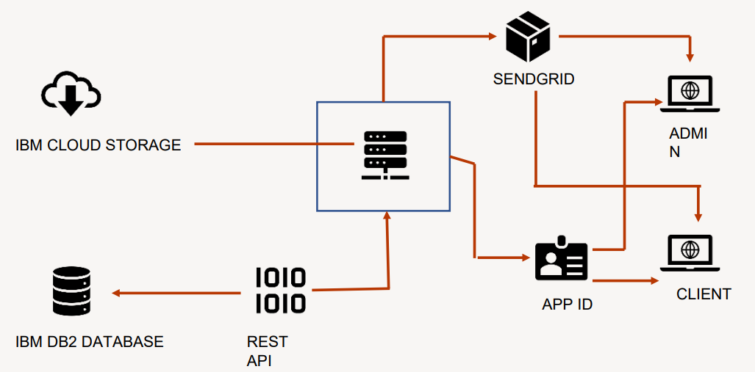

Table-1: Components & Technologies:

|  |  |  |  |
| --- | --- | --- | --- |
| **S. No** | **Component** | **Description** | **Technology** |
| 1. | User Interface | How user interacts with application e.g. Web UI, Chatbot etc. | HTML, CSS. |
| 2. | Application Logic-1 | Logic for a process in the application | Python |
| 3. | Application Logic-2 | Logic for a process in the application | IBM Watson STT service |
| 4. | Application Logic-3 | Logic for a process in the application | IBM Watson Assistant |
| 5. | Database | Data Type, Configurations etc. | SQL |
| 6. | Cloud Database | Database Service on Cloud | IBM DB2, IBM Cloud ant etc. |
| 7. | File Storage | File storage requirements | IBM Block Storage or Other Storage Service or Local Filesystem |
| 8. | Infrastructure (Server / Cloud) | Application Deployment on Local System / Cloud Local Server Configuration:  Cloud Server Configuration: | Local, Cloud Foundry, Kubernetes, etc. |

Table-2: Application Characteristics:

|  |  |  |  |
| --- | --- | --- | --- |
| **S. No** | **Characteristics** | **Description** | **Technology** |
| 1. | Open-Source Frameworks | List the open-source frameworks used | Python Flask |
| 2. | Security Implementations | List all the security / access controls implemented, use of firewalls etc. | Encryptions, Intrusion Detection Software, Antivirus, Firewall. |
| 3. | Scalable Architecture | Justify the scalability of architecture (3 – tier, Micro-services) | Support higher workloads without any fundamental changes to it. |
| 4. | Availability | Justify the availability of application (e.g., use of load balancers, distributed servers etc.) | High availability enables your IT infrastructure to perform even when  some of its components fail. |

|  |  |  |  |
| --- | --- | --- | --- |
| **S. No** | **Characteristics** | **Description** | **Technology** |
| 5. | Performance | Design consideration for the performance of the application (number of requests per sec, use of Cache, use of CDN’s) etc. | Performance Technology, therefore is a field of practice that uses various tools, processes, and ideas in a scientific, sematic manner to improve the desired outcomes of individuals and  organizations. |